
St Peter’s RC Primary School
74, Dunbar St, Aberdeen AB24 3UJ tel 01224 485611
e-mail stpeters@aberdeenschools.org.uk
Headteacher Mrs Jo Martin
Term 1 Newsletter 2 29th September 2014
www.st-peters.aberdeen.sch.uk

Please remember to return
- The blue form for ‘Routine and Expected Outings.’ This form gives class teachers permission to take your child out on trips to Aberdeen Sports Village, Tillydrone Library, Seaton Park, Aberdeen University, shops and other local amenities. We are blessed to have a range of educational opportunities in our area and we like to be able to make the most of them, sometimes arranging trips at short notice if the weather is good and we have sufficient adult help.
- The letter to the NHS about flu vaccinations. If you have any questions at all about this, please contact our School Nurse, Gillian McLeod, on
A team of nurses will be in school on Wednesday 12th November to vaccinate all children whose permission slips are returned by Thursday 2nd October.
- The slip about Parents’ Night. All the teachers will be in the hall on Parents’ Nights (Wednesday 8th and Thursday 9th October) and the accompanying letter offers you a ten minute appointment. Please complete the slip so we know if you will be able to come along.


Happy playtimes

We have introduced two changes to our playtime routines this session.

- Children are allowed to play in any part of the playground except the
‘Quiet Zone’ for P6 and P7 at the side of Old Aberdeen House.
- If it rains, children can choose to play out as long as they have a
jacket with a hood and wear sensible shoes. They will be supervised
at all times. Nobody is forced to play outside when the weather is bad.

Please remind your child that the staff in the playground want to help them to enjoy their breaks. Staff watch for children who seem to be lonely or unhappy. They are also vigilant about preventing bullying and rough play. Please encourage your child to speak up about anything that upsets them.

Our playground rules are

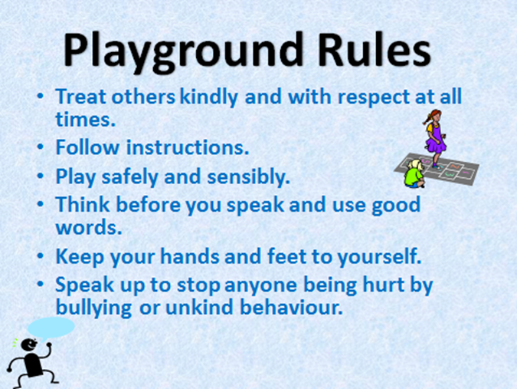
Playground staff are:
Mrs Black, Mrs Craig, Mrs Campbell, Mrs Kennedy, Mrs McKinlay, Mrs Simpson and Mrs Wilson.
They work on rota and we have at least three staff out at all times.

All the children know that they should walk along the GREEN PATHS in the car park area.
Adults, please help us all to keep our children safe.


.
Please remember that the only vehicles allowed in our car park are staff cars, delivery vehicles and official school transport. There is plenty of space to ‘park and stride’ from Seaton Park or Lidl. Please show consideration and help to keep our school grounds safe for all our children. Thank you.
Please do not bring cars into the school car park.

Dates for your Diary
Monday 29th September
We welcome a student teacher, Miss Dooley, who will be working with Mr McFadden in P7 this term.
Tues 30th Sept | Swimming at the Aquatics Centre – P7, P6, P5 and P3. Parent Helpers welcome.
Wed 1st Oct | PE lessons for P2, P4, P5, P6 and P7  4.15pm – 5.15pm Mandarin classes resume at the Confucius Institute for pupils who went last year. Please contact them on confucius@abdn.ac.uk or 01224 273209
Thurs 2nd Oct | National Poetry Day  P3 trip to Macduff Marine Aquarium  Swimming at Northfield Pool – P4  4.15 – 5.15pm After-School Mandarin class at the Confucius Institute for pupils who have not learned Mandarin before. Parents can book in their children by contacting confucius@abdn.ac.uk or 01224 273209
Fri 3rd Oct | Basic Moves at ASV Parent helpers are very welcome.  9.30 P3/4 Pupils leave at 9am to walk there  10.15 P2 Pupils leave on the bus at 9.45am  11 P1/2 Pupils leave on the bus at 10.30am  Teachers and teacher trainers from Germany are visiting our school this morning.  2pm Harvest Festival. Please send donations of canned goods eg soup, beans, fruit, vegetables….or food in packets eg flour, pasta, rice, tea, sugar….Parents and friends are very welcome. The donations will go to the SVP and Seaton Food Bank.
Tues 7th Oct | Aqua Fun at the Aquatics Centre – P7, P6, P5 and P3. Parent helpers are very welcome. Assemblies –Missionary Children – Day of Many Colours
Wed 8th Oct | 3.30pm – 6pm Parent-Teacher meetings in the hall.
Thurs 9th Oct | TechFest outreach workshops  9.30 – 10.15 P5 Investigating Ink  10.45 – 11.30 P6 Investigating Ink  1pm – 2pm P7 Microbiology. Pupils need to bring an old clean sock.  3.30pm – 6pm Parent-Teacher meetings in the hall.
Fri 10th Oct | Basic Moves at ASV Parent helpers are very welcome.  9.30 P3 Pupils leave at 9am to walk there  10.15 P1 red Pupils leave on the bus at 9.45am  11 P1 blue Pupils leave on the bus at 10.30am
Mon 13th Oct – Fri 24th Oct ‘TATTIE’ HOLIDAY
Wed 29th Oct | 9.30 – 11.30am ‘Gathered Together’ project in the hall run by Donna Cuthill, Aberdeen City Parental Involvement officer, and Richa Okhandiar, Participation and Development Officer at BEMIS - Black and Ethnic MInority Infrastructure in Scotland. All parents are very welcome.  12 – 3 P4 trip to Duthie Park for Rainforest Workshop Parent helpers are very welcome.
Thurs 30th Oct | Fancy Dress Party for P1 and P2. More details to follow.
Fri 31st Oct | Basic Moves at ASV for P3, P1 red and P1 blue Parent helpers are very welcome.  Fancy Dress Disco for P3 – P7. More details to follow.
Mon 17th Nov | In-Service Day. Children do not attend school.
Mon 22nd Dec – Friday 2nd January CHRISTMAS HOLIDAY

